Project Design Phase-II
Data Flow Diagram & User Stories

Date | 31 August 2026
Project Name | Automated Network Request Management in ServiceNow
Maximum Marks | 4 Marks

Data Flow Diagram:
The Data Flow Diagram shows how a network request moves through the Automated Network Request Management system in ServiceNow. The employee submits the request through the Service Catalog. The system collects the required details, creates a network request record, sends it for approval, and processes the request using Flow Designer. The request is then updated based on the approval and processing status, and notifications are sent to the concerned users.

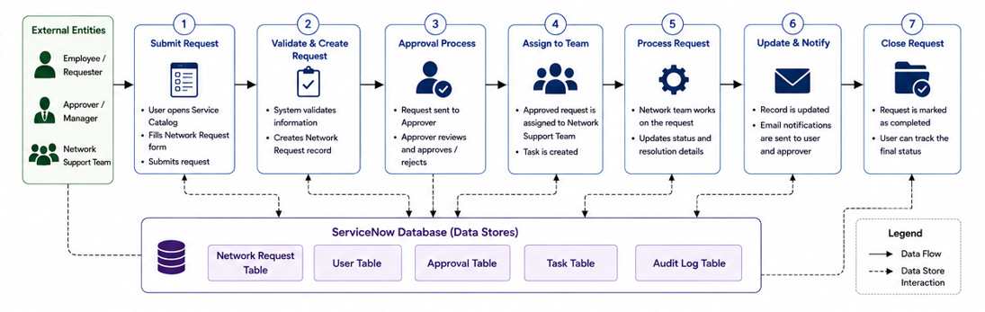

User Stories:
The user stories define the key requirements of the Automated Network Request Management in ServiceNow system from the perspective of employees, approvers, network support teams, and administrators. They describe how users submit, approve, process, track, and manage network requests, while automation handles record creation, workflow, notifications, and reporting.

User Type | Functional Requirement (Epic) | User Story Number | User Story / Task | Acceptance criteria | Priority | Release
Employee / Requester | Network Request Submission | USN-1 | As an employee, I can submit a network request through the Service Catalog. | The request is submitted successfully with all required details. | High | Sprint-1
Employee / Requester | Request Information | USN-2 | As an employee, I can enter connection, address, device, and requester details in the network request form. | All entered information is captured correctly in the request. | High | Sprint-1
Employee / Requester | Dynamic Request Form | USN-3 | As an employee, I can see relevant fields based on the connection type and device type I select. | Only the required/relevant fields are displayed based on the selected options. | High | Sprint-1
Employee / Requester | Request Tracking | USN-4 | As an employee, I can view the current status of my network request. | The current request status is displayed correctly. | Medium | Sprint-2
Approver / Manager | Request Approval | USN-5 | As an approver, I can review and approve or reject a network request. | The approver can approve or reject the request and the decision is recorded. | High | Sprint-1
Approver / Manager | Approval Processing | USN-6 | As an approver, I receive a network request automatically for approval after submission. | An approval request is generated automatically for the concerned approver | High | Sprint-1
Network Support Team | Request Assignment | USN-7 | As a network support team member, I can receive approved network requests for processing. | Approved requests are available to the appropriate support team | Medium | Sprint-2
Network Support Team | Request Processing | USN-8 | As a network support team member, I can process the request and update its status and resolution details. | Status and resolution information can be updated and saved successfully. | High | Sprint-3
System | Automated Workflow | USN-9 | As a system, I can automatically process network requests using Flow Designer. | The configured workflow performs the required actions automatically after request submission. | High | Sprint-1
System Administrator | Request Management | USN-10 | As an administrator, I can view and manage network request records. | The administrator can access, review, and manage request records. | Medium | Sprint-2
System Administrator | Reporting | USN-11 | As an administrator, I can generate reports to monitor network requests. | Reports display relevant request information such as status, category, or request volume. | Medium | Sprint-2
System | Automatic Record Creation | USN-12 | As a system, I can automatically create a network request record from the submitted catalog request. | A network request record is created with the submitted catalog information. | High | Sprint-1

